
PERIODIC TEST - I (2023-2024)
Subject: Computer Science  Grade: XII |  | Max. Marks: 35  Time: 80 mins
- Answer Key
 | SECTION A
1 | ALTER TABLE People DROP Primary Key; |  | 1
2 | Tuple |  | 1
3 | as |  | 1
4 | Foreign Key |  | 1
5 | DISTINCT |  | 1
6 | count(*) |  | 1
7 | 33 |  | 1
8 | none of the mentioned |  | 1
9 | Statement 4 and 5 |  | 1
10 | 8.0 |  | 1
11 | True |  | 1
 | SECTION -B
12 | i)  Manufaturer max(price)  ____________________________  LAK 40  ABC 55  XYZ 120  ii)  P.ProductName C.ClientName  ----------------------------  Face Wash Cosmetic Shop  Face Wash Pretty One  Shampoo Live Life  iii)  Max(Expirydate) Min(Price)  _____________________________  2012-04-09 40  iv)  P.P_ID P.Expirydate C.C_ID  -----------------------------  SH06 2012-04-09 12 |  | 2
13 | i)  MAKE  ----  Toyota  Tata  Renault  Suzuki  ii)  MAKE COUNT(*)  -----------------  Renault 2  Tata 2  iii)  CNAME  -----  Renault  Toyota  iv)  CNAME MAKE  --------------  Baleno 4000  Nano 3500 |  | 2
14 | Appno Name Subject City  ----------------------------  C02 Raju Hindi Madurai  C02 Raju Hindi Jaipur  Degree=4, Cardinality=2 |  | 2
15 |  |  | 2
16 | a) A is True but R is False  b)  T=(10,2,5,8,3)  X=sorted(T)  X[0]=-5  T+=(30,)  print(T) |  | 2
17. | - Given the Python string declaration, print the output  - Write the output of the following code given below:  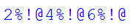 |  | 2
18. | IN- Condition based on list of values  BETWEEN-AND – Condition based on range |  | 2
19. | 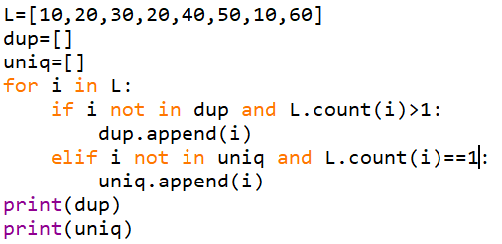 |  | 3
 | SECTION – C
20. | Consider the table Celebrity  i)  {CelebrityID,Phone}  ii)Degree=5, Cardinality=1  iii)  a.Insert into celebrity values(....);  b.update celebrity set feecharged=feecharged+200 where phone like '%6%';  c.select event,Feecharged*12 as "Annual" from celebrity;  d.alter table celebrity add grade char(1);  e.drop table celebrity; |  | 7
***

